Appendix 7: New Features in Version 3.4B
Here is a brief listing of some of the features new in Version 3.4B:

Accuracy:
Several refinements to the performance calculations have been made. We have also added a Preference “Use v3.4B Performance Calculations” where you can choose to use these new calculations, or revert back to the calculations very similar to used in v3.4A.

The program has added Direct Injection option for Combustion Chamber design The program now more realistically simulates cam profiles for OHC valve trains. The program has about 100 more example Complete Engine files.
The program has hundreds more example components, like Heads and Camshafts. GM LS Cams and Heads are now a separate category.

The program now shows "Peak Int. Sec. Tune RPM" in the Special Calculations section so you can see if the program is simulating Secondary Intake Tuning Effects.

New Roots type superchargers have been added similar to those in Engine Analyzer Pro: Modern Screw Type and Modern 2000+ Screw Type.

When reading Engine Analyzer Pro files, the program now better determines the individual port flow efficiencies when the file has a full flow curve.

The program has updated the Piston Speed recommendations in the Analyze Performance reports. AnalysisReport.txt is now done in Notepad for easier reading, printing, editing, copying, etc for the user. The Analysis Report also has an improved header for printouts.

Operation:
The program will now more reliably open your default internet browser to accessing the internet. Fixed bug where canceling from printing to a PDF printer could cause program to stop.
The Preview when opening a Saved File now includes more info about the engine.

The method for displaying a PDF file (like the User Manual) has been updated to be more compatible with more operating systems. The method for opening a file or page on the internet has been updated to be more compatible with more operating systems.
The program has eliminated repeating error messages, or repetitive questions about printing in landscape vs portrait orientation.

The program now keeps the Case (upper and lower) of the Graph Titles from History Log. This way what you enter will be displayed correctly on graphs.

The Graph menu items of Background Color, Grid Style, and labels for valve lift graphs to include TDC, BDC, are now properly marked with check marks for the current setting.

There is a new Preference “Use Larger Fonts on Output Grid” that lets you increase font size for calculations output data table. The Special Calculations section font has been changed to Courier New to allow for changing font size.

Many Help screens are now shown in Notepad so you can save or print them. Prior to this, they would be displayed on 1 or more separate screens without any options like printing.

Files and folders you delete are now actually sent to the Recycle Bin so they can be recovered later if you want.

Features have been added so input screens can be resized and the size and location is remembered for next time the screen is open. You can now stop displaying the Opening Warning screen when you start the program with a check box for “Don’t show this again”. Several screens have been increased in size to allow for longer file names, and to accommodate higher screen resolutions.
The program can now open newer versions of Engine Analyzer Pro files.

The program will now display all columns in History Log. Prior to this the columns of “Graph?” and “Graph Title” were sometimes hidden.

The program now allows Graph File Names up to 30 characters long.

A bug was fixed where the software would check for reasonable lash settings even if the cam was Hydraulic prior to calculations.

Now the list of Example components is not updated if the criteria box for searching is blank. For example, if you have requested to look for Duration less than some amount, but the text box for the amount is blank, the example list is not updated. This can make the process of searching for examples more efficient and quicker.

The program now explains why you can not open very old files from Engine Analyzer Pro, rather than just not opening them.

The Program now checks the configuration file after it is written and makes a backup copy. If a problem is sensed in the configuration file the next time the program starts, the backup configuration file is used.

The program has a bug fixed which avoids problems opening History Log on VERY high resolution screens.

Changed Preference "Main Screen Enlarged to Fill Screen" to "Main Screen Fonts Increase w Screen Size". Now you can also resize and reposition the main screen and it is remembered the next time you start the program. If you set this Preference to No, then the fonts will stay the original size, but the picture area will be large. If you set this Preference to Yes, then the fonts will grow in size, but the picture area will stay relatively small.

The program has a new Preference "Allow Input Screens to be Resized" to let you resize and reposition the component screens, like Short Block, Heads, etc. The size and position is remembered each time you open a screen, and the next time you start the program. Set this to No (the default) and the screens stay relatively small, stay in their default positions, and can be faster loading.

The default Font Size on the main screen is now larger to show up better on higher resolution screens, even without changing any Preferences.

The program has removed 2 Preferences: “Beginner User” setting and the option to not "Show Open/Close Events in Cam Specs". Most users wanted Experienced User features and the program to show the Cam Events.

There is now a "Make Microsoft Excel File" option for creating ASCII files from the calculated results.

Optimize Feature, Plus Version Only:
Several changes to the Optimize feature have been made, so that more accurate answers can be found for more possible combinations. For example, the program now assumes the optimum cam durations are larger if the RPM range for the calculations is high.

An Optimize option of "Only Check Cam Specs close to the original Specs" has been added. If the program's standard "Optimize" feature can not find optimum Cam Specs, turn on this option and the program may better find them.
When Optimizing, a display of “Valve Toss” or “Lifter Pump Up” for the combinations found has been added. This can help explain why an Optimum combination could not be found.

When Optimizing both Cam Duration and Lift, the lifts have been reduced some to be more realistic for typical cams.

If Optimize can not find better performance than the engine's original settings, the info message gives suggestions for changes to be made for it to work better at optimizing.

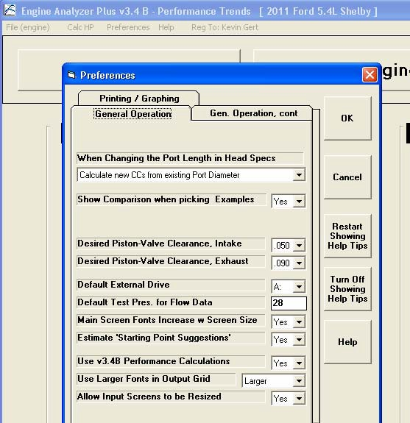
Figure B.01 Four (4) New Preferences in v3.4B
Click on Preferences to obtain screen below.
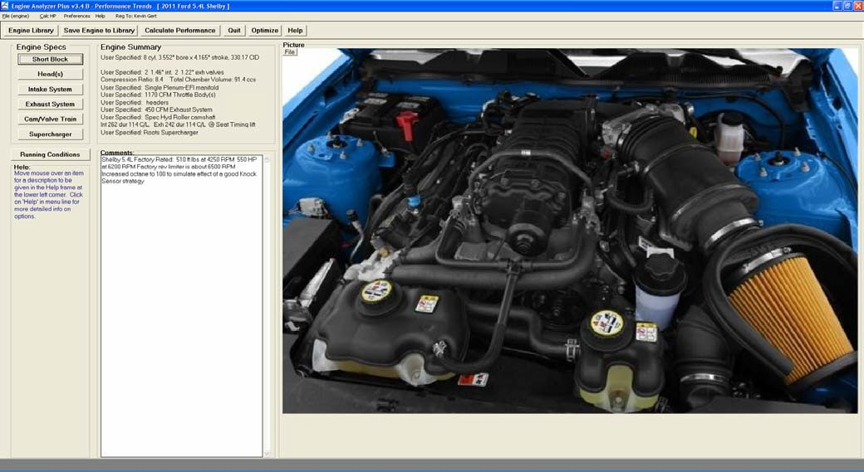
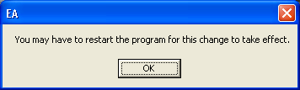
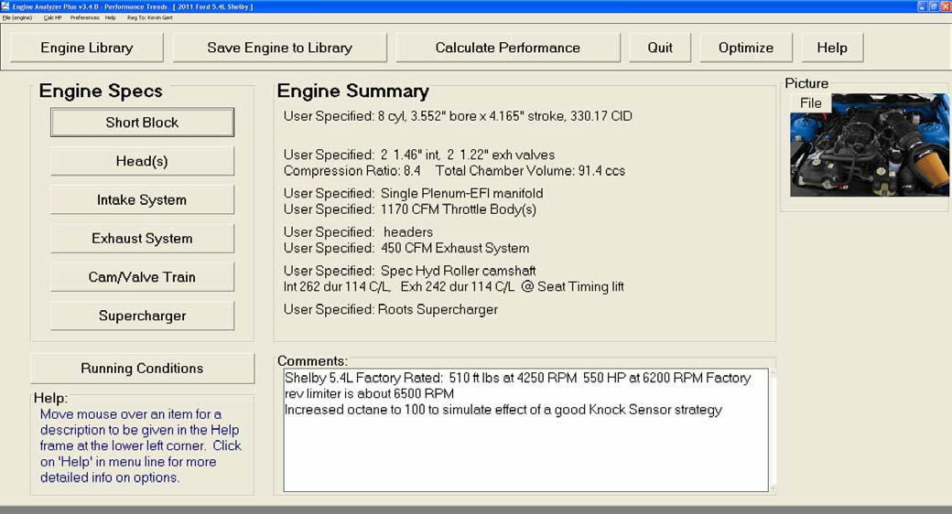
Figure B.02 Main Screen Fonts Increase w Screen Size
Set to No

Even set to No, the fonts are larger than in v3.4A

When you change this Preference, you will get this message. Restart the program to see the true effect.
Set to Yes.

Picture screen remains small

Fonts for most all items are much larger.
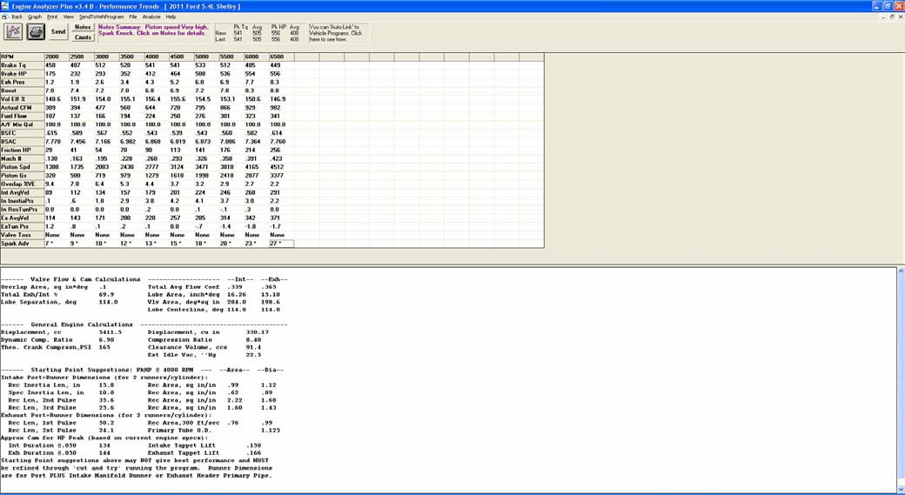
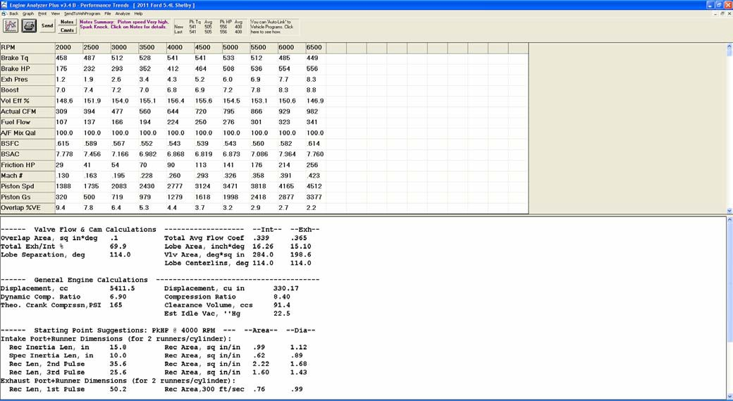
Figure B.03 Use Larger Fonts on Output Grid
Set to No

Set to Largest
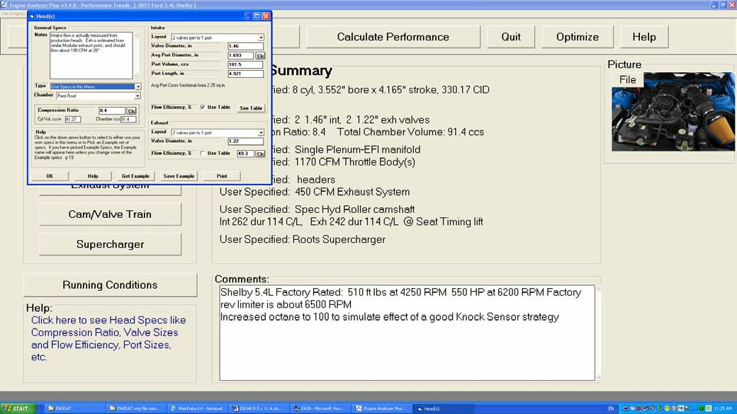
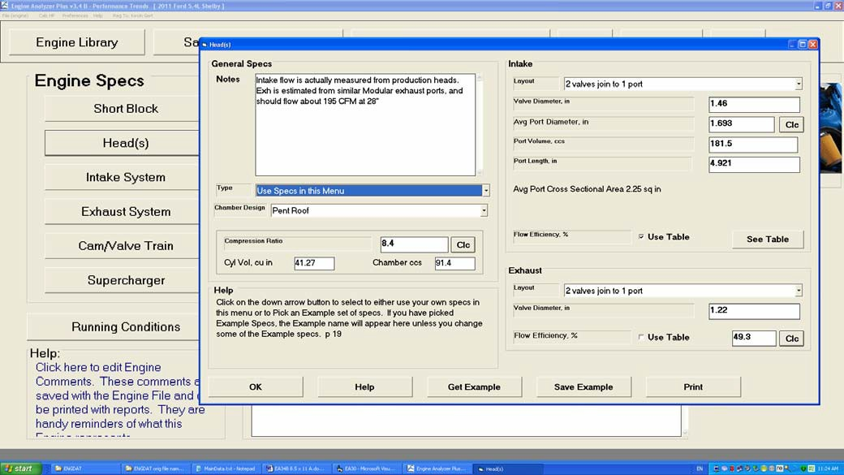
Figure B.04 Allow Input Screens to be Resized
Set to No

Set to Yes.
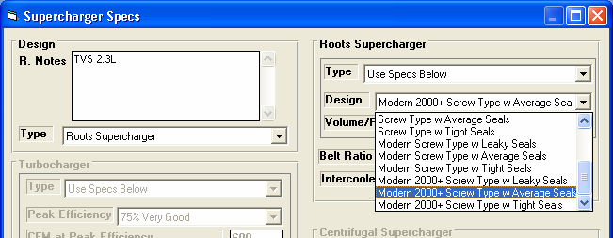
Figure B.05 New “Modern” Supercharger Designs

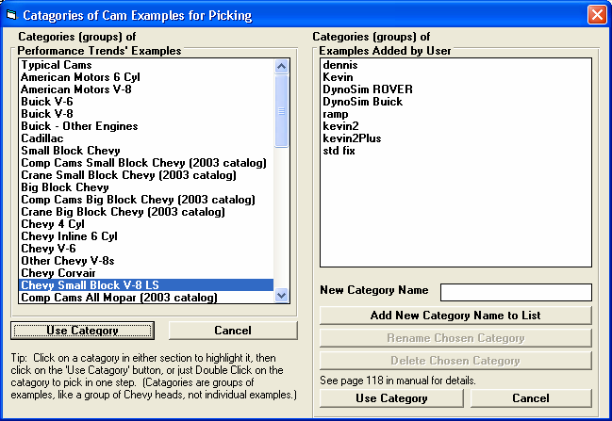
Figure B.06 New Chevy LS Categories for Example Components
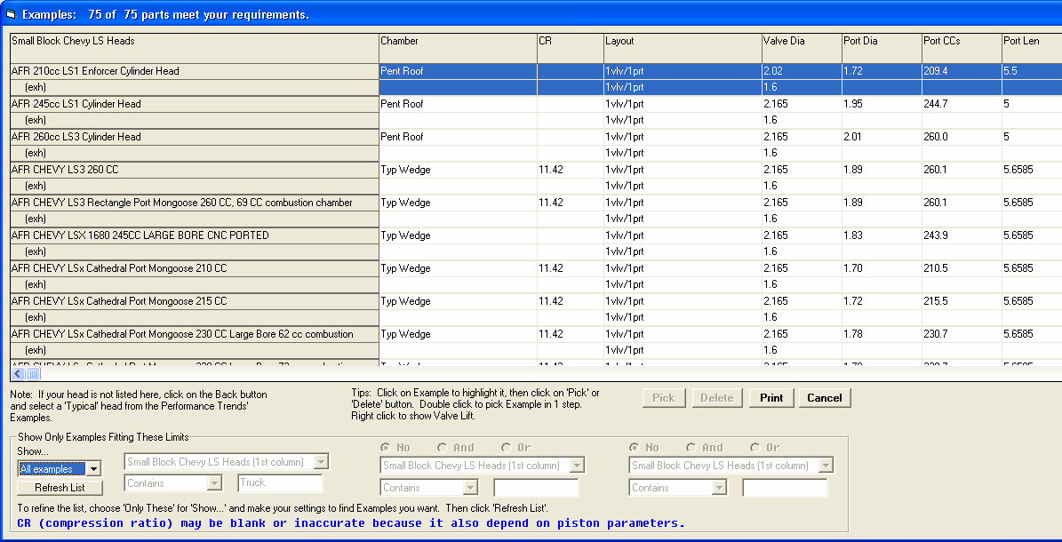
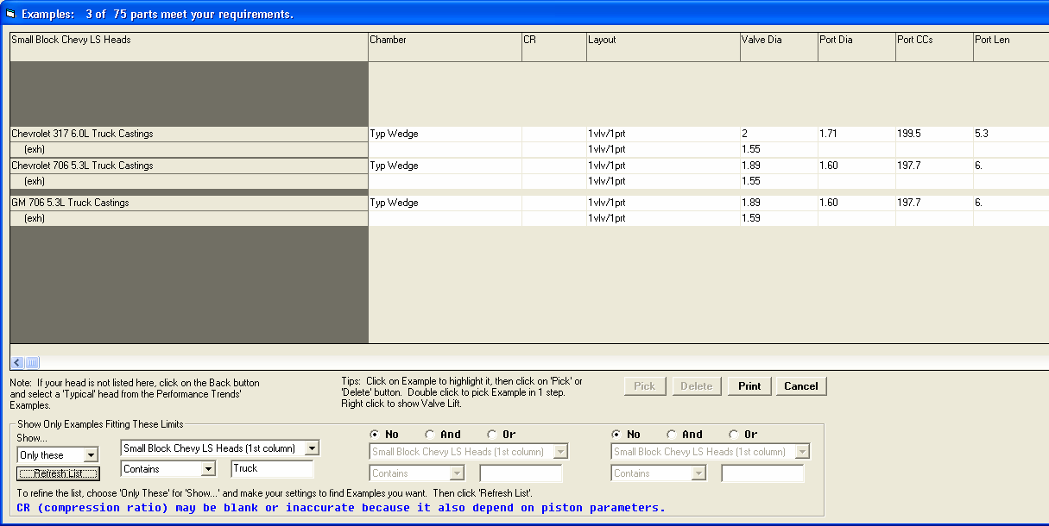
Figure B.07 Chevy LS Example Heads
New label showing how many examples fit the search criteria

Show All Examples

Show only Examples which contain the word Truck in the first column
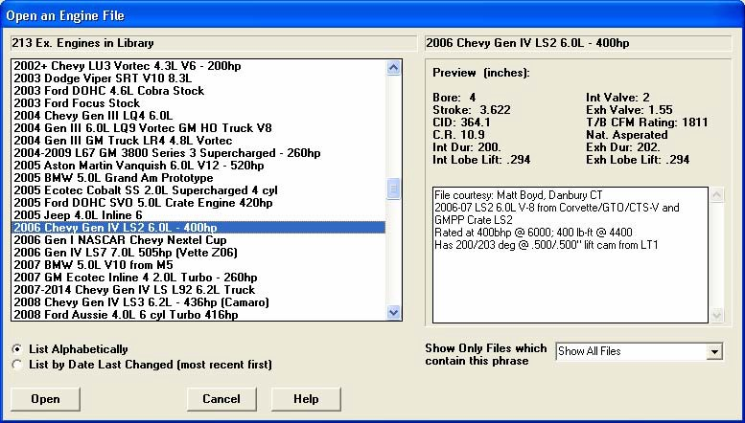
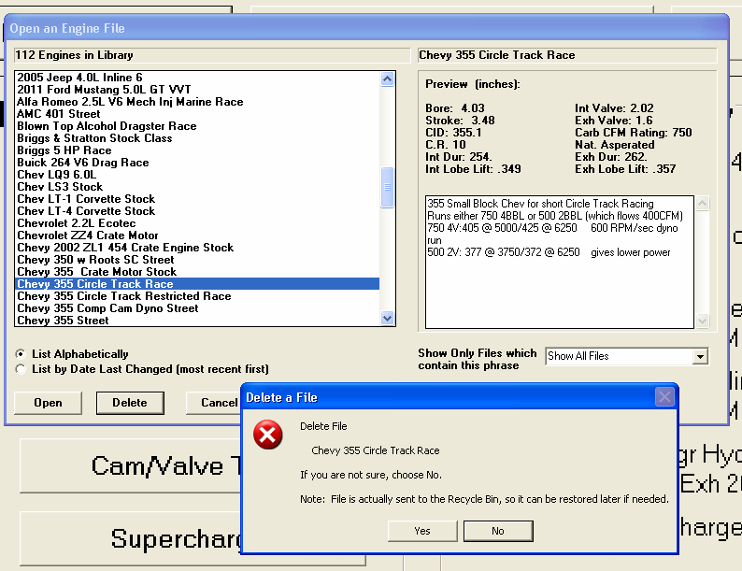
Now 213 Example Engines provided with program (was 112)
Figure B.08 More Example Complete Engines and Deleting Files

Screen is wider to allow for much longer file names

If you choose to Open one of your Saved Engine Files, highlight it by clicking on it, then select to Delete it, the file now goes to your computer’s Recycle bin.
This way you can restore it if you make a mistake. The Delete button is not shown if you choose to open an Example file provided with the program. You can not delete these files.
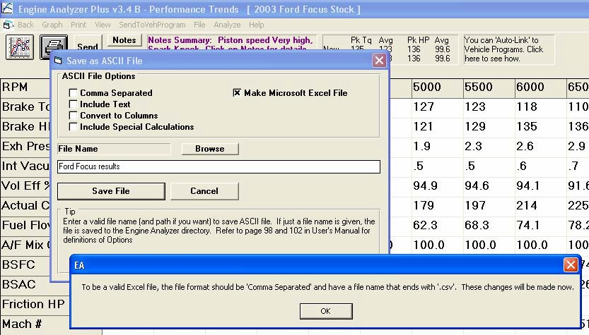
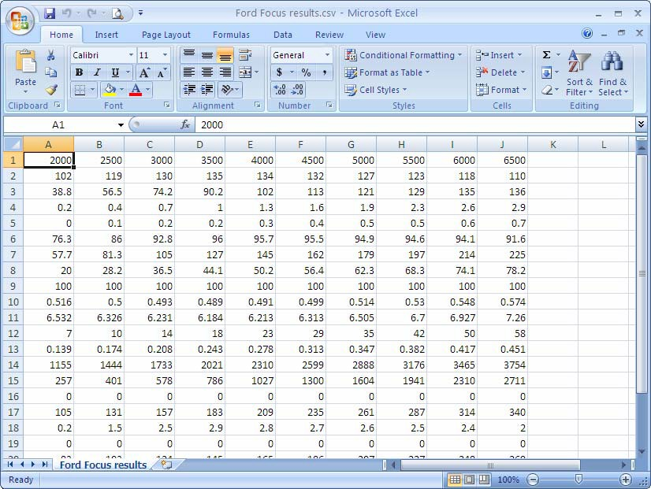
Figure B.09 Exporting Microsoft Excel File of Calculated Results
Click File to bring up screen
Check this box to make a Microsoft Excel file

Program tells you the changes it will make to create a valid Excel file.

File will open directly in Excel
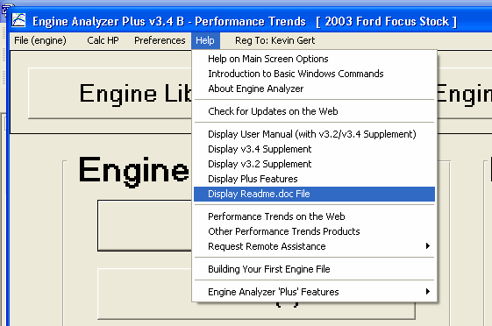
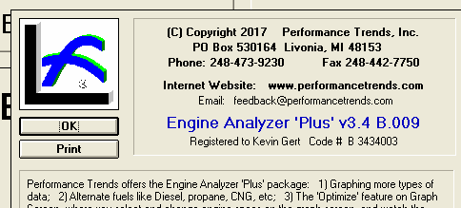
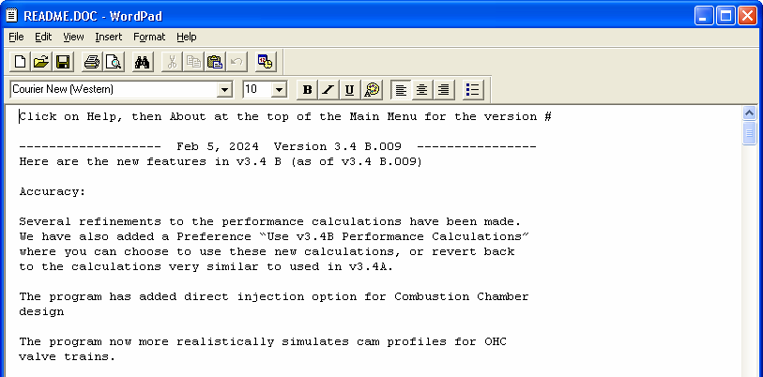
Click Help to bring up Help Options.
Click About… to see the complete version number for your software, like v3.4 B.012.
Click here to see the Readme.doc file on the web. Then you can see what updates have been published.
Displaying these PDF files should work better on most all computers.
Figure B.10 New Help Options

Click on About to see the complete version number for your program.

Check the Readme.doc file on the web to see the latest version which is available, and a list of updates since your program’s version. For example, if the Readme.doc file on the web showed updates up to v3.4 B.019, it should show you updates for the 10 minor version updates you have missed.
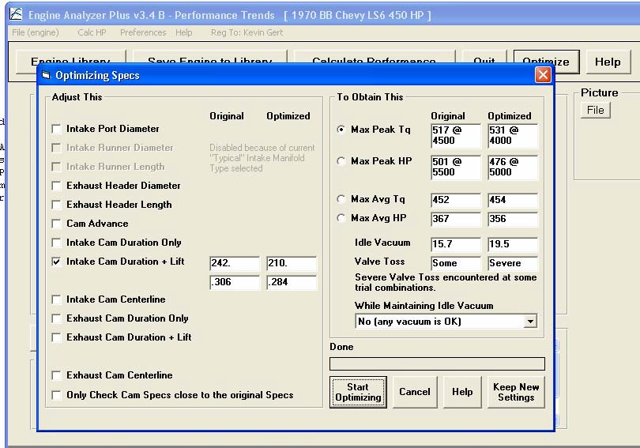
Figure B.11 New Optimize Features, Plus Version Only
Click the Optimize button to bring up this screen.
Some Intake or Exhaust specs may be disabled (grayed out) if the “Type” in their screens is set to a Generic Type, like “Typical Street Dual Plane”.

Valve Toss or Lifter Pump Up is shown here. If either is encountered, power may be significantly limited at some of the RPMs tested.

This message can give info on how to interpret the results. For example, if Severe Valve Toss is encountered, you should maybe improve the valve train design and try again. Or you should realize that power may be limited by Valve Toss in the RPM range tested.
If you think the current cam specs are near optimum, check this box. Then the program will concentrate only on cam specs fairly similar to what your current cam specs are. Otherwise the program could try durations from, say, 160 to 340 degrees, and could miss a combination close to what you have now.

